**Previous Billing Cycle - April 1 to April 30(All dues cleared on or before April 25)(Same as First Billing Cycle)**

* Grace Period **applicable** for April purchases

**Current Billing Cycle - May 1 to May 31**

**Due Date: May 25**

**1.a (Cleared all previous due on or before 25th) 🡪 Verified(No issue)**

* No interest is charged in the May month billing statement.

**credit card id =3842 - Mbanq stage default tenant**

1/4/23 =Card creation

1/4/23=Joining fee=40$

15/4/23=Purchase transaction (1000$) +MCC charge (4$) =1004$

1/5/23=Running jobs

Interest accrued from 1/4/23 to 31/4/23 =10.69 (Reversal)

Outstanding balance = (1004+40) =1044$

Min due=50$ (2% of transaction amount)

25/5/23=Make payment (Clear all the outstanding balance (1044$) = **(Cleared all previous due on or before 25th))**

1/6/23=Again run the job (No transaction is made in May cycle)

Interest amount accrued from 1/5/23 to 25/5/23 reversed (15.44$) -Issue (C:\Users\vinod\Desktop\credit card execution\1.a_Credit card interest calculation template_5931.xlsx)

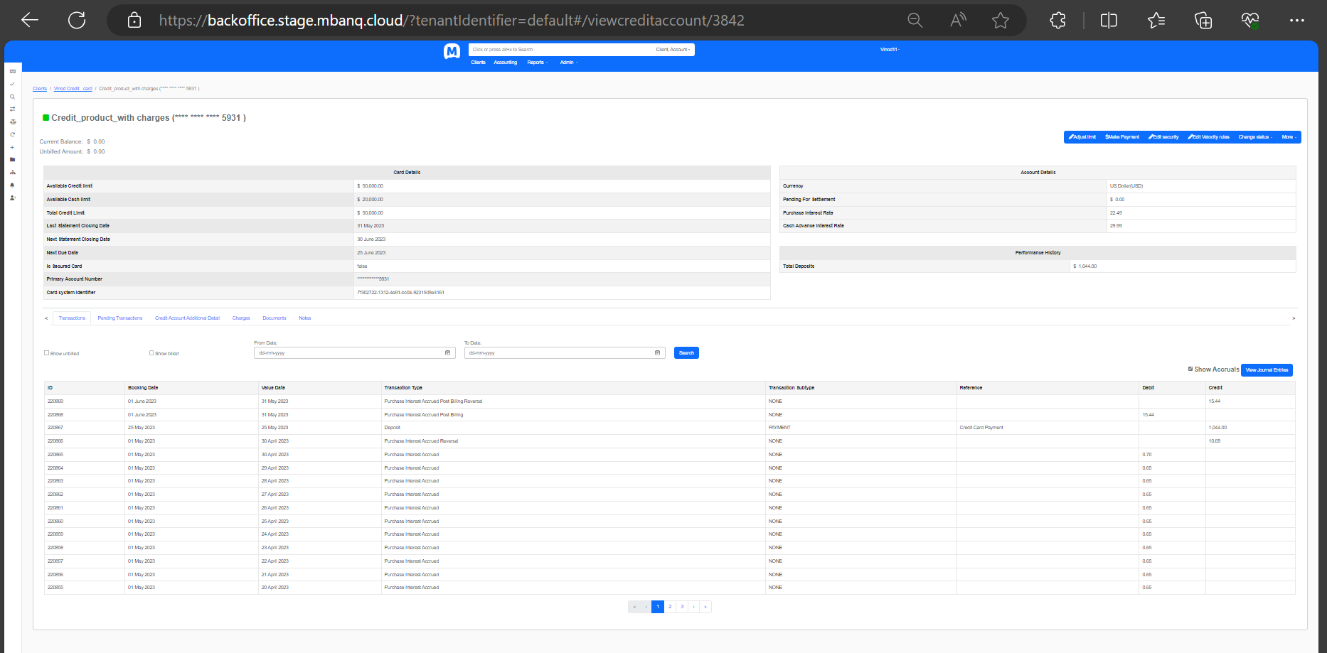

**1.b Cleared partial dues (>=Minimum Due) on or before May 25th - Verified(No issue)**

* Interest charged on unpaid balance only from May 1 to May 31 in the May month billing statement.
* Also, interest is charged on the May purchases(from the date of transaction settlement) as well since no grace period applied to May month.
  + *Example:*

*Bill generated for April month for $1000*  
*Minimum Due = $50*  
*Payment received on 25th May = $100>Minimum Due*  
*Interest charged from May 1-May 31 on balance : $1000-$100=$900*

*Interest charged from May 1-May 31 on May purchases from date of transaction of such purchases*

* Afterwards, no grace period will be applicable to June month as well and interest on the pending dues for May will continue to accrue.

**credit card id =3843 - Mbanq stage default tenant**

1/4/23 =Card creation

1/4/23=Joining fee=40$

15/4/23=Purchase transaction (1000$) +MCC charge (4$) =1004$

1/5/23=Running jobs

Interest accrued from 1/4/23 to 31/4/23 =10.69 (Reversal)

Outstanding balance = (1004+40) =1044$

Min due=50$ (2% of transaction amount)

25/5/23= Make payment 100$ (**Cleared partial dues (>=Minimum Due) on or before May 25th)**

25/5/23=Purchase transaction (1000$) +MCC charge (4$) =1004$

1/6/23=Again run the job

Interest calculated for 944$ (1044 $-100$) from May 1st to May 31st for April outstanding balance is = 18.20$

Interest calculated for 1004$ from May 25th to May 31st for May cycle purchase = 4.34$

Total interest charged = 18.20+4.34 = **22.54$**

Total outstanding balance at the end of May cycle is = (944+18.20+1004+4.34) = **1970.54$**

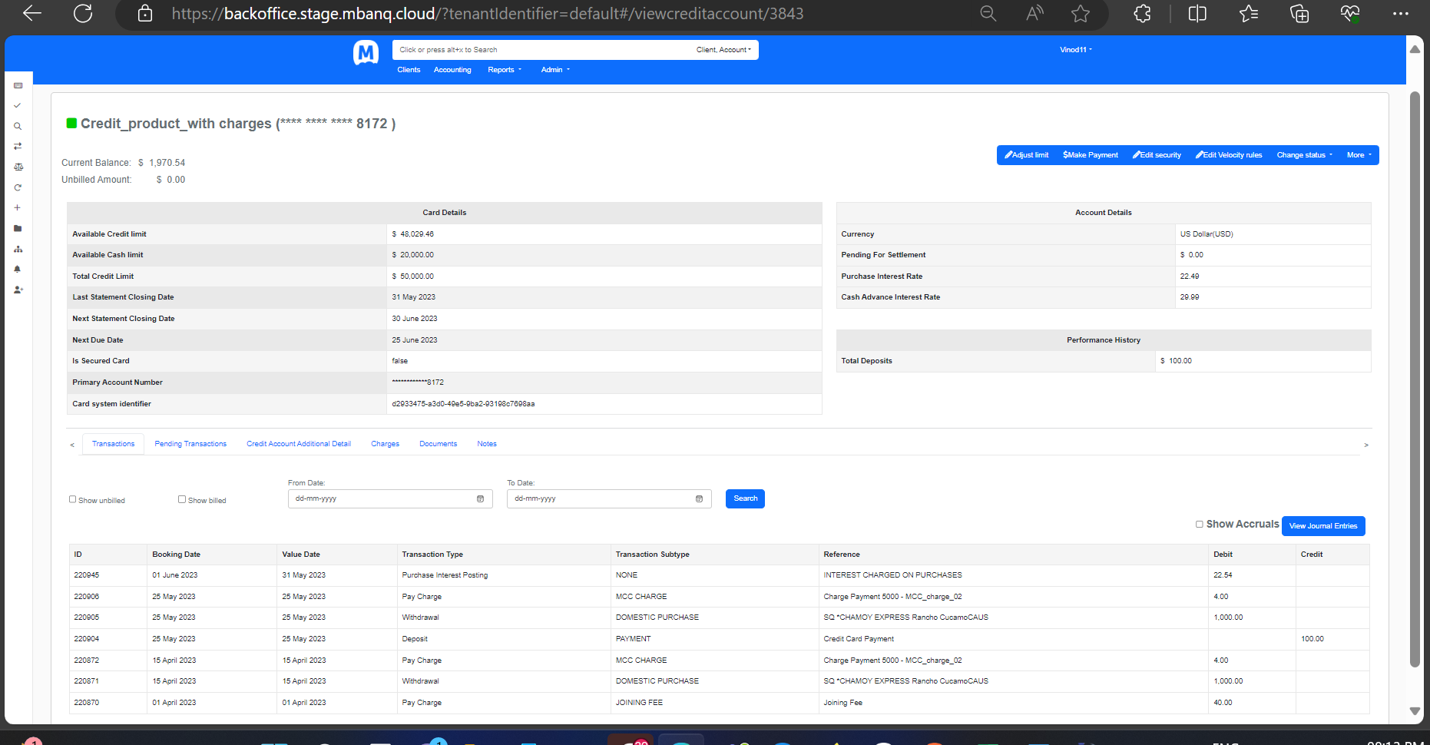

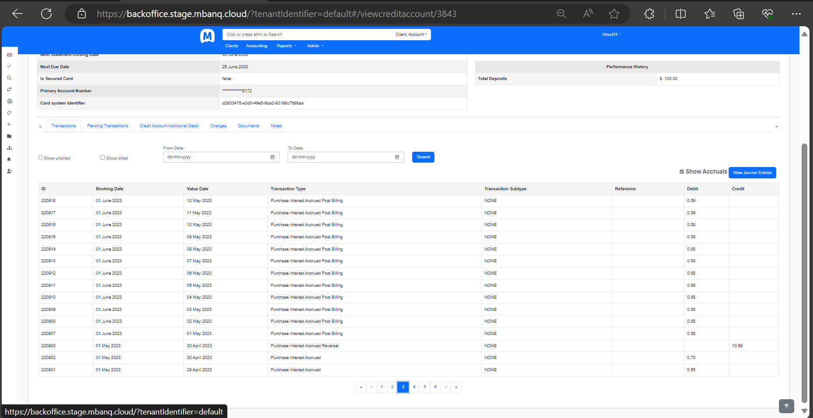

**1.c.1 Amount paid <Minimum Due paid during the month of May  - Verified(No issue)**

* Interest charged on whole April balance only from May 1 to May 31 in the May end statement. However, there will be no interest charge applied to April purchases for the month of April since April purchases were eligible for interest free grace period on account of all previous dues cleared by April 25.
* Also, interest is charged on the May purchases (from the date of transaction settlement) as well since no grace period applied to May month.
* Afterwards, no grace period will be applicable to June month as well and interest on the pending dues for May will continue to accrue.
* Late Fee applicable.
  + *Example 1:*

*Bill generated for April month for $1000*  
*Minimum Due = $50*  
*Payment received on 25th May = $30<Minimum Due*  
*Interest charged from May 1-May 24 on balance : $1000*  
*Interest charged from May 25-May 31 on balance : $1000-$30=$970*

*Interest charged from May 1-May 31 on May purchases from date of transaction of such purchases*

*late payment fee*

**credit card id =3851 -Mbanq stage default tenant**

1/4/23 =Card creation

1/4/23=Joining fee=40$

15/4/23=Purchase transaction (1000$) +MCC charge (4$) =1004$

1/5/23=Running jobs

Interest accrued from 1/4/23 to 31/4/23 =10.69 (Reversal)

Outstanding balance = (1004+40) =1044$

Min due=50$ (2% of transaction amount)

25/5/23= Make payment 30$ (**Amount paid <Minimum Due paid during the month of May)**

25/5/23=Purchase transaction (1000$) +MCC charge (4$) =1004$

31/5/23 = Late payment fee = 40$

1/6/23=Again run the job

Interest calculated for 1044$ from May 1st to May 24th for April outstanding balance is = 15.55$

Interest calculated for 1014$(1040$-30$) from May 25th to May 31st for April outstanding balance is = 4.46$

Total interest charged for previous cycle = 15.55$+4.46$ = 20.01 round off (20.00$)

Interest calculated for 1004$ from May 25th to May 31st for May cycle purchase = 4.37$ round off (4.36$)

Total interest charged as per excel = 20.00+4.36 = **24.36$**

**Total interest charged as per system = 24.34$**

**Mismatch = 0.02 Cents**

Total outstanding balance at the end of May cycle is = (1014+20+4.36+40+1000+4) = **2082.36$**

**1.c.2 No Amount paid <Minimum Due paid during the month of May - Verified(No issue)**

**Note: Late Payment Fee should not be included in the current cycle for interest computation in the excel**

*Example 2:*

*Bill generated for April month for $1000*  
*Minimum Due = $50*  
*No* *Payment received during the month of May*   
*Interest charged from May 1-May 31 on balance*: *$1000*

*Interest charged from May 1-May 31 on May purchases from date of transaction of such purchases*

**credit card id =3852 -Mbanq stage default tenant**

1/4/23 =Card creation

1/4/23=Joining fee=40$

15/4/23=Purchase transaction (1000$) +MCC charge (4$) =1004$

1/5/23=Running jobs

Interest accrued from 1/4/23 to 31/4/23 =10.69 (Reversal)

Outstanding balance = (1004+40) =1044$

Min due=50$ (2% of transaction amount)

25/5/23= **Do not Make any payment 0$** (No **Amount paid <Minimum Due paid during the month of May)**

25/5/23=Purchase transaction (1000$) +MCC charge (4$) =1004$

31/5/23 = Late payment fee = 40$

1/6/23=Again run the job

Interest calculated for 1044$ from May 1st to May 31st for April outstanding balance is = 20.11$ round off (20.13$)

Interest calculated for 1044$ from May 25th to May 31st for May cycle purchase = 4.37$ round off (4.36$)

Total interest charged as per excel = 20.13+4.36 = **24.49$**

**Total interest charged as per system = 24.47$**

**Mismatch = 0.02 Cents**

Total outstanding balance at the end of May cycle is = (1000+4+40+20.13+4.36+40+1000+4) = **2112.49$**

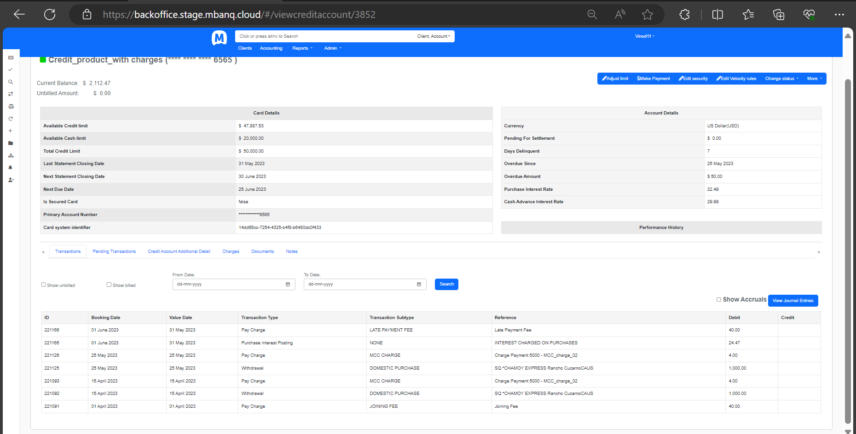

**1.d Cleared partial dues (>=Minimum Due) on or before May 28th (i.e., after May 25 but on or before May 31) - Verified(No issue)**

**Note: Late Payment Fee should not be included in the current cycle for interest computation in the excel**

* Interest charged on the whole of previous statement balance from **May 1 till May 27**
* **May 28 onwards,** interest will be charged on the previous statement unpaid amount after adjusting the daily balance by the amount of partial payment received on May 28.
* Also, interest is charged on the May purchases(from the date of transaction settlement) for the entire May month billing cycle since no grace period applies to May month.
  + *Example:*

*Bill generated for April month for $1000*  
*Minimum Due = $50*  
*Payment received on 28th May = $100>Minimum Due*  
*Interest charged from May 1-May 27 on balance : $1000*  
*Interest charged from May 28-May 31 on balance : $1000-$100=$900*

*Interest charged from May 1-May 31 on May purchases from date of transaction of such purchases*

* Afterwards, no grace period will be applicable to June month as well and interest on the pending dues for May will continue to accrue.
* Late Fee applicable.

**credit card id =3853 -Mbanq stage default tenant**

1/4/23 =Card creation

1/4/23=Joining fee=40$

15/4/23=Purchase transaction (1000$) +MCC charge (4$) =1004$

1/5/23=Running jobs

Interest accrued from 1/4/23 to 31/4/23 =10.69 (Reversal)

Outstanding balance = (1004+40) =1044$

Min due=50$ (2% of transaction amount)

25/5/23=Purchase transaction (1000$) +MCC charge (4$) =1004$

28/5/23= Make payment 100$ (**Amount paid >=Minimum Due paid on May 28th**

31/5/23 = Late payment fee = 40$

1/6/23=Again run the job

Interest calculated for 1044$ from May 1st to May 27th for April outstanding balance is = 17.50$

Interest calculated for 944$(1040$-100$) from May 28th to May 31st for April outstanding balance is = 2.36$

Total interest charged for previous cycle = 17.50$+2.36$ = 19.86 round off (19.88$)

Interest calculated for 1004$ from May 25th to May 31st for May cycle purchase = 4.37$ round off (4.36$)

Total interest charged as per excel = 19.88+4.36 = **24.24$**

**Total interest charged as per system = 24.22$**

**Mismatch = 0.02 Cents**

Total outstanding balance at the end of May cycle is = (944+24.22+40+1000+4) = **2012.24$** = as per system

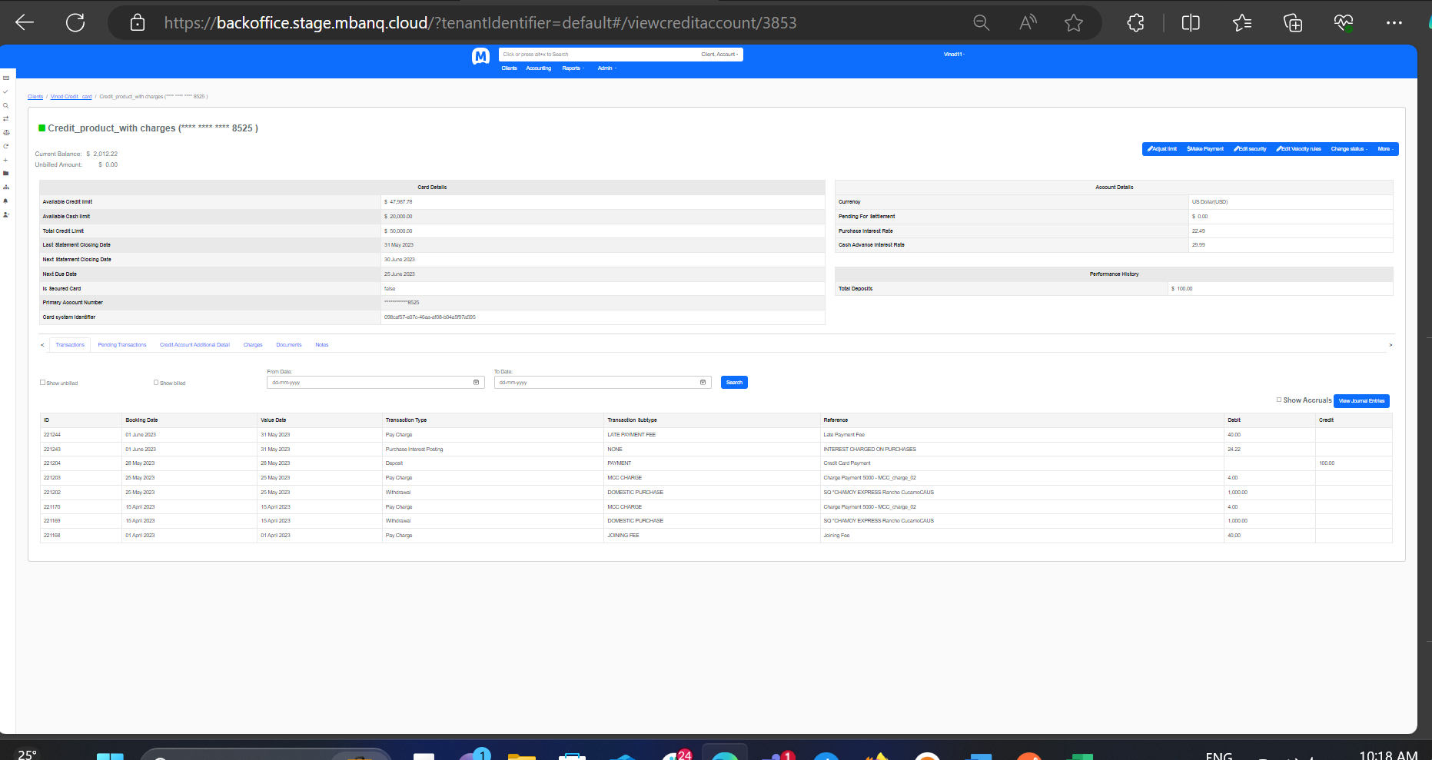

### **1.e Cleared whole of the Previous balance (Payment Amount=Previous Statement Balance) on May 28 (i.e., after May 25 but on or before May 31) - Verified(No issue)**

* Interest charged on the whole of previous bill balance from **May 1 till May 27**.
* **May 28 onwards,** there will be no further interest accruals related to the previous bill balance since previous bill balance is fully cleared now. However, interest continues to get accrued on the already accrued interest on the previous bill balance based on the daily balance calculation and the same shall be carried forward to the June billing cycle along with any other accrued interest for the May cycle purchases.
  + *Example:*

*Bill generated for April month for $1000*  
*Minimum Due = $50*  
*Payment received on 28th May = $1000(Full payment due)*  
*Interest charged from May 1-May 27 on balance : $1000*  
*No* *Interest charged from May 28-May 31 on April balance*

*Interest charged from May 1-May 27 on May purchases from date of transaction of such purchases*

*No* *Interest charged from May 28-May 31 on May purchases*

*Interest continues to* ***accrue on the already accrued interest*** *on the April balance($1000) from May 28-May 31 and the same shall be carried forward to the June billing cycle.*

*Interest continues to* ***accrue on the already accrued interest*** *on May purchases and any new purchases from May 28-May 31* *and the same shall be carried forward to the June billing cycle.*

* Also, interest is charged on the May month purchases(from the date of transaction settlement) from **May 1 till May 27**. **May 28 onwards**, interest accrual on the May month purchases will continue but it **shall not** be posted at the end of May billing cycle and **carried forward to the June billing cycle as accrued interest** only to be posted at the end of June billing cycle along with any further interest accrued if the May billing cycle dues are not cleared by June 25.
* **If May billing cycle dues are fully cleared on or before June 25, any accrued interest carried forward from the May month billing cycle to the June month shall be reversed along with any accrued interest on June month purchases.**
* Grace period **will be applicable** to June month billing cycle, provided May billing cycle dues are fully cleared by June 25.
* Late Fee applicable.

**credit card id =3854 -Mbanq stage default tenant**

1/4/23 =Card creation

1/4/23=Joining fee=40$

15/4/23=Purchase transaction (1000$) +MCC charge (4$) =1004$

1/5/23=Running jobs

Interest accrued from 1/4/23 to 31/4/23 =10.69 (Reversal)

Outstanding balance = (1004+40) =1044$

Min due=50$ (2% of transaction amount)

25/5/23=Purchase transaction (1000$) +MCC charge (4$) =1004$

28/5/23= Make payment 1044$ **Cleared whole of the Previous balance (Payment Amount=Previous Statement Balance) on May 28 (i.e., after May 25 but on or before May 31)**

31/5/23 = Late payment fee = 40$

1/6/23=Again run the job

Total Interest calculated for 1044$ from May 1st to May 27th for April outstanding balance is = 17.51$

Interest calculated for 1004$ from May 25th to May 27th for May cycle purchase = 1.86$

Total interest charged as per excel = 17.51+1.86 = **19.37$**

**Total interest charged as per system = 19.37$**

Total outstanding balance at the end of May cycle is = (17.51+1.86+40+1000+4) = **1063.37$** = as per system

No issue on above scenario

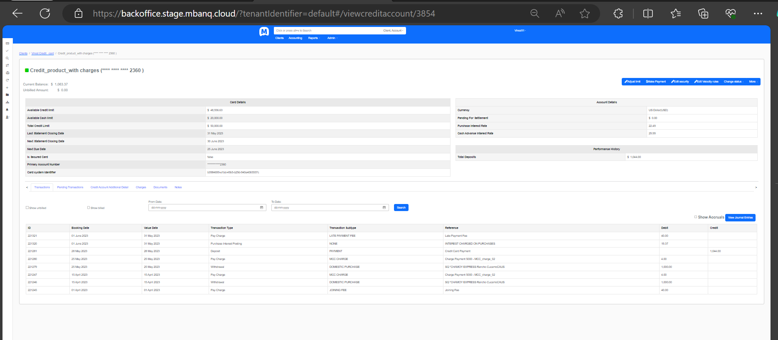

## **Case 2: Previous Billing Cycle - April 1 to April 30 (All dues not cleared on or before April 25)**

* Grace Period **not Applicable** for **April and May** purchases
* April Bill generated at the end of April billing cycle includes the following:
  + Interest on unpaid March statement balance as applicable
  + Interest on April purchases from date of transaction to end of statement cycle i.e. April 30

**Current Billing Cycle - May 1 to May 31**

**Due Date: May 25**

### Case 2a: Cleared all previous dues on or before May 25

* Interest charged on **unpaid April statement balance** **from May 1 to the payment date**, as applicable.
* Interest charged on **May purchases from transaction date to the full payment date.**
* However, interest continues to get accrued on the already accrued interest on the April balance based on the daily balance calculation and the same shall be carried forward to the June billing cycle along with any other accrued interest for the May cycle purchases.
  + *Example:*

*Bill generated for April month for $1000*  
*Minimum Due = $50*  
*Payment received on May 25 = $1000(Full payment due)*  
*Interest charged from May 1-May 24 on April balance: $1000*  
*No* *Interest charged from May 25-May 31 on April balance*

*Interest charged from May 1-May 24 on May purchases from date of transaction of such purchases*  
*No* *Interest charged from May 25-May 31 on May purchases.*

*Interest continues to* ***accrue on the already accrued interest*** *on the April balance ($1000) from May 25-May 31 and the same shall be carried forward to the June billing cycle.*

*Interest continues to* ***accrue on the already accrued interest*** *on May purchases and any new purchases from May 25-May 31* *and the same shall be carried forward to the June billing cycle.*

* Grace period **will be applicable** to June month billing cycle, provided May billing cycle dues are fully cleared by June 25.
* **credit card id =3856 - Mbanq stage default tenant**

**March cycle = 1st cycle**

* 1/3/23 =Card creation
* 1/3/23=Joining fee=40$
* 15/3/23=Purchase transaction (1000$) +MCC charge (4$) =1004$
* 1/4/23=Running jobs
* Interest accrued from 1/3/23 to 31/3/23 =10.69 (Reversal)
* Outstanding balance = (1000+4+40) **=1044$**

**April cycle = 2nd cycle**

* Previous cycle (March cycle) outstanding balance = 1044$
* 15/4/23=Purchase transaction (1000$) +MCC charge (4$) =1004$
* 1/5/23=Running jobs
* Interest accrued from 1/4/23 to 31/4/23 for march outstanding balance (1044$) =19.47$ (As per excel)
* Interest accrued from 15/4/23 to 31/4/23 for April purchase (1004$) = 9.97$(As per excel)
* Total interest accrued for April cycle = 19.47+9.97= 29.44$ (As per excel)
* Total interest accrued as per system for April cycle = 29.41$ (As per system)
* Mismatch = 0.03 cents for April cycle
* 31/4/23=Late payment fees = 40$
* Total outstanding balance for April cycle (As per system) = (1044+1004+29.41+40) = 2117.41
* Total outstanding balance for April cycle (As per excel) = (1044+1004+29.44+40) = 2117.44 mismatch 0.03cents

**May cycle = 3rd cycle**

* Previous cycle (April cycle) outstanding balance **= 2117.41$** (As per system)
* 25/5/23 =Purchase transaction (1000$) +MCC charge (4$) =1004$
* 25/5/23 = Make payment 2117.41(clear all previous dues on or before May 25th)
* Interest accrued from May 1st to May 24th for April month outstanding balance (2117.41$) is = 31.54$ (Same as System and as per excel)
* Interest accrued for May cycle purchase from May 25th to May 31st is =4.19$ (Carried forward for June cycle).
* 1/6/23 Run the jobs.
* Total outstanding balance for May cycle (As per excel) = (31.54+1000+4) = 1035.54$ as per excel and as per system

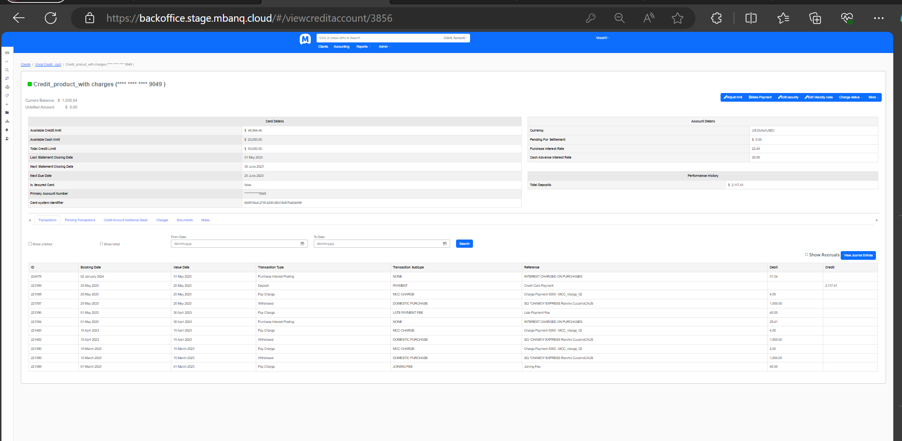

### Case 2b: Cleared Partial dues (>= Minimum Due) **May 23** (i.e., on or before May 25)

* Interest charged on **all** **unpaid April statement balance from May 1 till May 22**.
* Interest charged on **remaining** **unpaid** **April** balance **from May 23 till May 31**.
* Interest charged on the **May** purchases **from the date of transaction settlement till May 31**.
  + *Example:*

*Bill generated for April month for $1000*  
*Minimum Due = $50*  
*Payment received on May 23 = $200>Minimum Due*  
*Interest charged from May 1-May 22 on April balance: $1000*  
*Interest charged from May 23-May 31 on April balance: $800*

*Interest charged from May 1-May 31 on May purchases from date of transaction of such purchases.*

* Afterwards, no grace period will be applicable to June month as well and interest on the pending dues for April and May will continue to accrue.
* **credit card id = 4136 - Mbanq stage default tenant**

**March cycle = 1st cycle**

* 1/3/23 =Card creation
* 1/3/23=Joining fee=40$
* 15/3/23=Purchase transaction (1000$) +MCC charge (4$) =1004$
* 1/4/23=Running jobs
* Interest accrued from 1/3/23 to 31/3/23 =10.69 (Reversal)
* Outstanding balance = (1000+4+40) **=1044$**

**April cycle = 2nd cycle**

* Previous cycle (March cycle) outstanding balance = 1044$
* 15/4/23=Purchase transaction (1000$) +MCC charge (4$) =1004$
* 1/5/23=Running jobs
* Interest accrued from 1/4/23 to 31/4/23 for march outstanding balance (1044$) =19.47$ (As per excel)
* Interest accrued from 15/4/23 to 31/4/23 for April purchase (1004$) = 9.97$(As per excel)
* Total interest accrued for April cycle = 19.47+9.97= 29.44$ (As per excel)
* Total interest accrued as per system for April cycle = 29.41$ (As per system)
* Mismatch = 0.03 cents for April cycle
* 31/4/23=Late payment fees = 40$
* Total outstanding balance for April cycle (As per system) = (1044+1004+29.41+40) = 2117.41
* Total outstanding balance for April cycle (As per excel) = (1044+1004+29.44+40) = 2117.44 mismatch 0.03cents

**May cycle = 3rd cycle**

* Previous cycle (April cycle) outstanding balance **= 2117.41$** (As per system)
* 20/5/23 =Purchase transaction (1000$) +MCC charge (4$) =1004$
* 23/5/23 = Make payment 200$ (Cleared partial dues >=minimum due on May 23rd (on or before may May 25th)
* Interest accrued from May 1st to May 22nd for April month outstanding balance (2117.41$) is = 28.90$ (as per excel)
* Interest accrued from May 22nd to May 31st for April month remaining outstanding balance (2117.41$-200$ = 1917.41$) is = 10.81$
* Total interest accrued from May 1st to May 31st for April month outstanding balance is = (28.90+10.81) $ = 39.71$ (as per excel)
* Interest accrued for May cycle purchase from May 20th to May 31st is = 7.47$
* 1/6/23 Run the jobs.
* Total outstanding balance for May cycle (As per excel) = (39.71+1000+4+7.47+1917.41) = 2968.59$ (as per excel)
* Total outstanding balance for May cycle (As per system) = (39.71+1000+4+7.47+1917.41) = 2968.57$ (as per system)
* Mismatch = 0.02 cents

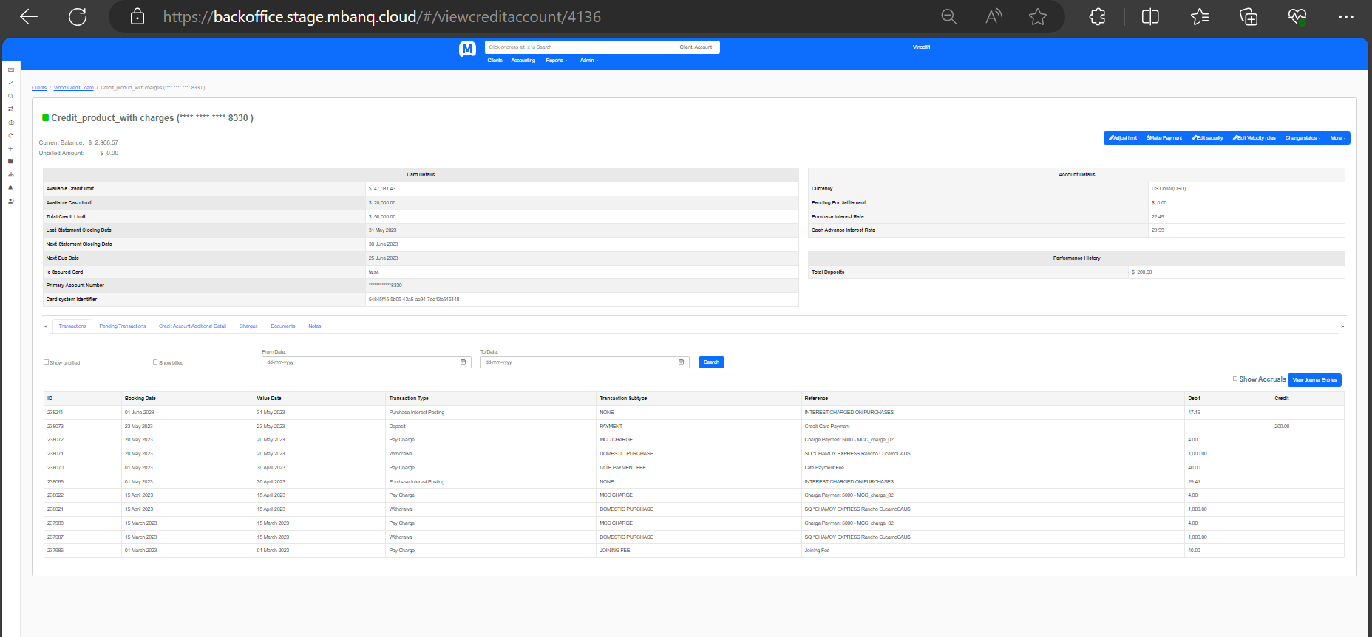

### Case 2c: 1. Amount < Minimum Due, paid during the month of May.

* Interest charged on **all** **unpaid April statement balance from May 1 till May 31** in the May end statement.
* Also, interest is charged on the May month purchases **from the date of transaction settlement** **till May 31** since no grace period applied to May month.
  + *Example 1:*

*Bill generated for April month for $1000*  
*Minimum Due = $50*  
*Payment received on May 23 = $30<Minimum Due*  
*Interest charged from May 1-May 22 on April balance: $1000*  
*Interest charged from May 23-May 31 on April balance: $970*

*Interest charged from May 1-May 31 on May purchases from date of transaction of such purchases.*

* Afterwards, no grace period will be applicable to June month as well and interest on the pending dues for May will continue to accrue.
* Late fee applicable.
* **credit card id = 4137 - Mbanq stage default tenant**

**March cycle = 1st cycle**

* 1/3/23 =Card creation
* 1/3/23=Joining fee=40$
* 15/3/23=Purchase transaction (1000$) +MCC charge (4$) =1004$
* 1/4/23=Running jobs
* Interest accrued from 1/3/23 to 31/3/23 =10.69 (Reversal)
* Outstanding balance = (1000+4+40) **=1044$**

**April cycle = 2nd cycle**

* Previous cycle (March cycle) outstanding balance = 1044$
* 15/4/23=Purchase transaction (1000$) +MCC charge (4$) =1004$
* 1/5/23=Running jobs
* Interest accrued from 1/4/23 to 31/4/23 for march outstanding balance (1044$) =19.47$ (As per excel)
* Interest accrued from 15/4/23 to 31/4/23 for April purchase (1004$) = 9.97$(As per excel)
* Total interest accrued for April cycle = 19.47+9.97= 29.44$ (As per excel)
* Total interest accrued as per system for April cycle = 29.41$ (As per system)
* Mismatch = 0.03 cents for April cycle
* 31/4/23=Late payment fees = 40$
* Total outstanding balance for April cycle (As per system) = (1044+1004+29.41+40) = 2117.41
* Total outstanding balance for April cycle (As per excel) = (1044+1004+29.44+40) = 2117.44 mismatch 0.03cents

**May cycle = 3rd cycle**

* Previous cycle (April cycle) outstanding balance **= 2117.41$** (As per system)
* 23/5/23 =Purchase transaction (1000$) +MCC charge (4$) =1004$
* 23/5/23 = Make payment 50$ (Cleared amount <minimum due on May 23rd (on or before may May 25th)
* Interest accrued from May 1st to May 22nd for April month outstanding balance (2117.41$) is = 28.90$ (as per excel)
* Interest accrued from May 22nd to May 31st for April month remaining outstanding balance (2117.41$-50$ = 2067.41$) is = 11.65$
* Total interest accrued from May 1st to May 31st for April month outstanding balance is = (28.90+11.65) $ = 40.55$ rounding off (40.54$) (as per excel)
* Interest accrued for May cycle purchase from May 23th to May 31st is = 5.61$
* 1/6/23 Run the jobs.
* Total Interest accrued for both April and May cycle purchase from May 1st to May 31st is = 40.54$+5.61$ = 46.15$ (As per EXCEL)
* Total Interest accrued for both April and May cycle purchase from May 1st to May 31st is = 46.12$ (As per system)
* Mismatch = 0.03cents
* Total outstanding balance for May cycle (As per excel) = (2067.41+46.15+1000+4+40) = 3157.56$ (as per excel)
* Total outstanding balance for May cycle (As per system) = (2067.41+46.12+1000+4+40) = 3157.53$ (as per system)
* Mismatch = 0.03 cents

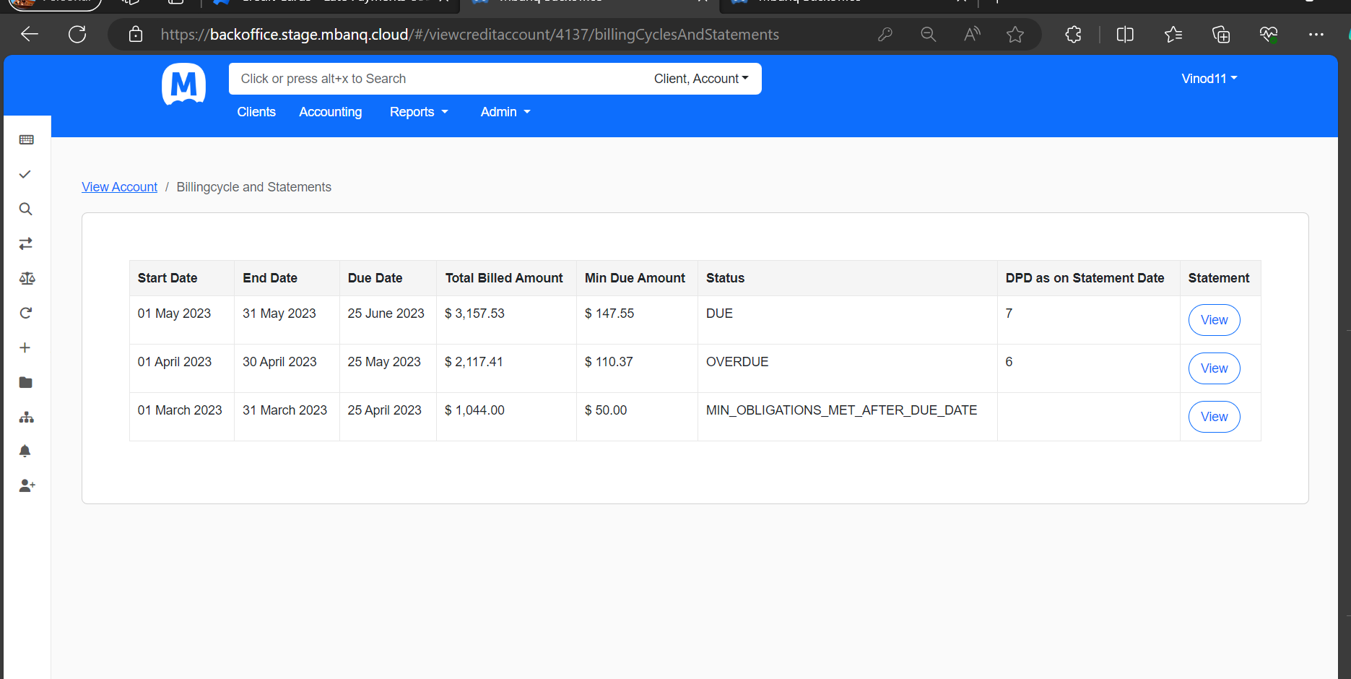

### Case 2c: 2. No amount < Minimum Due, paid during the month of May

* Interest charged on **all** **unpaid April statement balance from May 1 till May 31** in the May end statement.
* Also, interest is charged on the May month purchases **from the date of transaction settlement** **till May 31** since no grace period applied to May month.

*Example 2:*

*Bill generated for April month for $1000*  
*Minimum Due = $50*  
*No* *Payment received during the month of May*  
*Interest charged from May 1-May 31 on April balance: $1000*

*Interest charged from May 1-May 31 on May purchases from date of transaction of such purchases.*

* Afterwards, no grace period will be applicable to June month as well and interest on the pending dues for May will continue to accrue.
* Late fee applicable.
* **credit card id = 4139 - Mbanq stage default tenant**

**March cycle = 1st cycle**

* 1/3/23 =Card creation
* 1/3/23=Joining fee=40$
* 15/3/23=Purchase transaction (1000$) +MCC charge (4$) =1004$
* 1/4/23=Running jobs
* Interest accrued from 1/3/23 to 31/3/23 =10.69 (Reversal)
* Outstanding balance = (1000+4+40) **=1044$**

**April cycle = 2nd cycle**

* Previous cycle (March cycle) outstanding balance = 1044$
* 15/4/23=Purchase transaction (1000$) +MCC charge (4$) =1004$
* 1/5/23=Running jobs
* Interest accrued from 1/4/23 to 31/4/23 for march outstanding balance (1044$) =19.47$ (As per excel)
* Interest accrued from 15/4/23 to 31/4/23 for April purchase (1004$) = 9.97$(As per excel)
* Total interest accrued for April cycle = 19.47+9.97= 29.44$ (As per excel)
* Total interest accrued as per system for April cycle = 29.41$ (As per system)
* Mismatch = 0.03 cents for April cycle
* 31/4/23=Late payment fees = 40$
* Total outstanding balance for April cycle (As per system) = (1044+1004+29.41+40) = 2117.41
* Total outstanding balance for April cycle (As per excel) = (1044+1004+29.44+40) = 2117.44 mismatch 0.03cents

**May cycle = 3rd cycle**

* Previous cycle (April cycle) outstanding balance **= 2117.41$** (As per system)
* 23/5/23 =Purchase transaction (1000$) +MCC charge (4$) =1004$
* 23/5/23 = no payment (No amount <minimum due paid during the month on May)
* Total interest accrued from May 1st to May 31st for April month outstanding balance is = (40.83$ rounding off (40.82$) (as per excel)
* Interest accrued for May cycle purchase from May 23th to May 31st is = 5.61$
* 1/6/23 Run the jobs.
* Total Interest accrued for both April and May cycle purchase from May 1st to May 31st is = 40.82$+5.61$ = 46.43$ (As per EXCEL)
* Total Interest accrued for both April and May cycle purchase from May 1st to May 31st is = 46.40$ (As per system)
* Mismatch = 0.03cents
* Total outstanding balance for May cycle (As per excel) = (2117.41+46.43+1000+4+40) = 3207.84$ (as per excel)
* Total outstanding balance for May cycle (As per system) = (2117.41+46.40+1000+4+40) = 3207.81$ (as per system)
* Mismatch = 0.03 cents

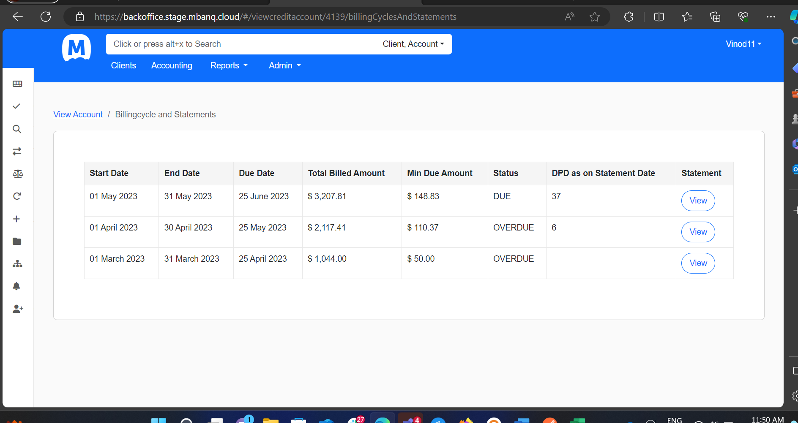

### Case 2d: Cleared Partial dues (>= Minimum Due) on **May 28** (i.e., after May 25 but on or before May 31)

* Interest charged on **all unpaid April statement balance from May 1 till May 27**.
* Interest charged on **remaining** **unpaid** **April** balance **from May 28 till May 31**.
* Also, interest is charged on the May month purchases **from the date of transaction settlement till May 31** since no grace period applies to May month.
  + *Example:*

*Bill generated for April month for $1000*  
*Minimum Due = $50*  
*Payment received on May 28 = $200>Minimum Due*  
*Interest charged from May 1-May 27 on April balance: $1000*  
*Interest charged from May 28-May 31 on April balance: $800*

*Interest charged from May 1-May 31 on May purchases from date of transaction of such purchases.*

* Afterwards, no grace period will be applicable to June month as well and interest on the pending dues for May will continue to accrue.
* Late Fee applicable.
* **credit card id = 4175 - Mbanq stage default tenant**

**March cycle = 1st cycle**

* 1/3/23 =Card creation
* 1/3/23=Joining fee=40$
* 15/3/23=Purchase transaction (1000$) +MCC charge (4$) =1004$
* 1/4/23=Running jobs
* Interest accrued from 1/3/23 to 31/3/23 =10.69 (Reversal)
* Outstanding balance = (1000+4+40) **=1044$**

**April cycle = 2nd cycle**

* Previous cycle (March cycle) outstanding balance = 1044$
* 15/4/23=Purchase transaction (1000$) +MCC charge (4$) =1004$
* 1/5/23=Running jobs
* Interest accrued from 1/4/23 to 31/4/23 for march outstanding balance (1044$) =19.47$ (As per excel)
* Interest accrued from 15/4/23 to 31/4/23 for April purchase (1004$) = 9.97$(As per excel)
* Total interest accrued for April cycle = 19.47+9.97= 29.44$ (As per excel)
* Total interest accrued as per system for April cycle = 29.41$ (As per system)
* Mismatch = 0.03 cents for April cycle
* 31/4/23=Late payment fees = 40$
* Total outstanding balance for April cycle (As per system) = (1044+1004+29.41+40) = 2117.41
* Total outstanding balance for April cycle (As per excel) = (1044+1004+29.44+40) = 2117.44 mismatch 0.03cents

**May cycle = 3rd cycle**

* Previous cycle (April cycle) outstanding balance **= 2117.41$** (As per system)
* 23/5/23 =Purchase transaction (1000$) +MCC charge (4$) =1004$
* 28/5/23 = Make payment 200$ (Cleared Partial dues >= minimum due on May 28th.
* Interest accrued from May 1st to May 27th for April month outstanding balance (2117.41$) is = 35.51$ (as per excel)
* Interest accrued from May 28th to May 31st for April month remaining outstanding balance (2117.41$-200$ = 1917.41$) is = 4.81$
* Total interest accrued from May 1st to May 31st for April month outstanding balance is = (35.51+4.81) $ = 40.32$ rounding off (40.33$) (as per excel)
* Interest accrued for May cycle purchase from May 23rd to May 31st is = 5.61$
* 1/6/23 Run the jobs.
* Total Interest accrued for both April and May cycle purchase from May 1st to May 31st is = 40.33$+5.61$ = 45.94$ (As per EXCEL)
* Total Interest accrued for both April and May cycle purchase from May 1st to May 31st is = 45.91$ (As per system)
* Mismatch = 0.03cents
* Total outstanding balance for May cycle (As per excel) = (1917.41+45.94+1000+4+40) = 3007.35$ (as per excel)
* Total outstanding balance for May cycle (As per system) = (1917.41+45.91+1000+4+40) = 3007.32$ (as per system)
* Mismatch = 0.03 cents

### Case 2e: Cleared whole of the Previous balance(Payment Amount=Previous Statement Balance) on **May 28** (i.e., after May 25 but on or before May 31)

* Interest charged on **all unpaid April statement balance from May 1 till May 27**.
* Interest charged on the **May** month purchases **from the date of transaction settlement till May 27**.
* **May 28 onwards,** there will be no further interest charges related to the previous card balance since previous balance is fully cleared now.
* **May 28 onwards**, interest accrual on the May month purchases will continue but it **shall not** be posted at the end of May billing cycle and **carried forward to the June billing cycle as accrued interest** only to be posted at the end of June billing cycle along with any further interest accrued if the May billing cycle dues are not cleared by June 25.
  + *Example:*

*Bill generated for April month for $1000*  
*Minimum Due = $50*  
*Payment received on 28th May = $1000(Full payment due)*  
*Interest charged from May 1-May 27 on balance: $1000*  
*No* *Interest charged from May 28-May 31 on April balance*

*Interest charged from May 1-May 27 on May purchases from date of transaction of such purchases.*

*No* *Interest charged from May 28-May 31 on May purchases.*

*Interest continues to* ***accrue on the already accrued interest*** *on the April balance ($1000) from May 28-May 31 and the same shall be carried forward to the June billing cycle.*

*Interest continues to* ***accrue on the already accrued interest*** *on May purchases and any new purchases from May 28-May 31* *and the same shall be carried forward to the June billing cycle.*

* **If May billing cycle dues are fully cleared on or before June 25, any accrued interest carried forward from the May month billing cycle to the June month shall be reversed along with any accrued interest on June month purchases.**
* Grace period **will be applicable** to June month billing cycle, provided May billing cycle dues are fully cleared by June 25.
* Late Fee applicable.
* **credit card id = 4179 - Mbanq stage default tenant**

**March cycle = 1st cycle**

* 1/3/23 =Card creation
* 1/3/23=Joining fee=40$
* 15/3/23=Purchase transaction (1000$) +MCC charge (4$) =1004$
* 1/4/23=Running jobs
* Interest accrued from 1/3/23 to 31/3/23 =10.69 (Reversal)
* Outstanding balance = (1000+4+40) **=1044$**

**April cycle = 2nd cycle**

* Previous cycle (March cycle) outstanding balance = 1044$
* 15/4/23=Purchase transaction (1000$) +MCC charge (4$) =1004$
* 1/5/23=Running jobs
* Interest accrued from 1/4/23 to 31/4/23 for march outstanding balance (1044$) =19.47$ (As per excel)
* Interest accrued from 15/4/23 to 31/4/23 for April purchase (1004$) = 9.97$(As per excel)
* Total interest accrued for April cycle = 19.47+9.97= 29.44$ (As per excel)
* Total interest accrued as per system for April cycle = 29.41$ (As per system)
* Mismatch = 0.03 cents for April cycle
* 31/4/23=Late payment fees = 40$
* Total outstanding balance for April cycle (As per system) = (1044+1004+29.41+40) = 2117.41
* Total outstanding balance for April cycle (As per excel) = (1044+1004+29.44+40) = 2117.44 mismatch 0.03cents

**May cycle = 3rd cycle**

* Previous cycle (April cycle) outstanding balance **= 2117.41$** (As per system)
* 23/5/23 =Purchase transaction (1000$) +MCC charge (4$) =1004$
* 28/5/23 = Make payment **2117.41$** (Cleared whole of the previous balance on May 28th)
* Interest accrued from May 1st to May 27th for April month outstanding balance (2117.41$) is = 35.51$ (as per excel)
* Interest accrued from May 28th to May 31st for April month remaining outstanding balance (2117.41$-200$ = 1917.41$) is = 4.81$ (Carried forward for June month billing).
* Total interest accrued from May 1st to May 31st for April month outstanding balance is = 35.51$ (as per excel)
* Interest accrued for May cycle purchase from May 23rd to May 27 is = 3.10$
* Interest accrued for May cycle purchase from May 28th to May 31st is = 3.48$ (Carried forward for June month billing).
* Total interest accrued for both April outstanding balance and May month purchase till 27th May is = 35.51+3.10 = 38.61$
* 1/6/23 Run the jobs.
* Total interest accrued for both April outstanding balance and May month purchase till 27th May is = 35.51+3.10 = 38.61$ (As per EXCEL)
* Total Interest accrued for both April and May cycle purchase from May 1st to May 31st is = 38.61$ (As per system)
* Total outstanding balance for May cycle (As per excel) = (38.61+1000+4+40) = 1082.61$ (as per excel)
* Total outstanding balance for May cycle (As per system) = (38.61+1000+4+40) = 1082.61$ (as per system)



